A Collaboration Between
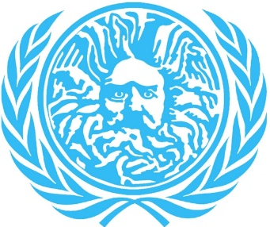

Conference Handbook

The Agenda

Day One: Friday the 15th of February 2019

Time | Event | Venue
16:00 | Delegation Registration | 8 West (8W) Foyer Management Department building on Campus
17:00 | Committee Icebreakers | 8W: 2.28, 2.34, 2.20, 2.23
18:00 | Opening ceremony & guest speaker | 8W3.22
19:45 | Formal Dinner & Social | Bath Function Rooms

Day Two: Saturday the 16th of February 2019

Time | Event | Venue
09:00 | First Sessions | EC: 8W2.27; DISEC: 8W2.28; SC: 8W2.34; spare: 8W2.13
12:00 | Staggered Lunch Break | Limetree, University Parade
13:30 | CRISIS Debate | 8W3.22
14:30 | Second Session | EC: 8W2.27; DISEC: 8W2.28; CRISIS: 8W2.20, 8W2.23, 8W2.30;

Day Three: Sunday the 17th of February 2019

Time | Event | Venue
10:30 | First Session | EC: 8W2.27; DISEC: 8W2.28; SC: 8W2.34; CRISIS 8W2.20, 8W2.23, 8W2.30,
12:15 | Staggered Lunch Break | Limetree, University Parade
13:30 | CRISIS Debates | 8W3.22
14:30 | Second Session | EC: 8W2.27; DISEC 8W2.28; SC:8W2.34; Crisis: 8W2.20, 8W2.23, 8W2.30,
16:00 | Closing Ceremony | 8W1.1

Committees
European Council:

Topic A: Defending Europe’s External Borders

Topic B: Increasing transparency within the EU institutions

Chair: Jack Lovejoy

Co-Chair: Anushka Dhar

Disarmament & International Security Council

Topic A: The militarisation of the Kashmir Region.

Topic B: Destruction of biological and chemical weapons of mass destruction

Chair: Kaan Akkaya

Co-Chair: Benjamin Hammett

Security Council:

Topic A: Crisis in Venezuela

Topic B: The Middle Eastern Cold War ​

Chair: Zoe Braddick

Co-Chair: Yaël Pelegrin

Crisis:

Topic: Bush v. Gore 2000 US Presidential Election

Crisis Co-Director: Mark Golding
Crisis Co-Director: Alex Golding

